***Open Source Graphics and Animation Tools***

***Assignment***

***Submitted to***

***Dr. Durgansh Sharma***

***Cybernetics SCS, UPES***

***Submitted By***

*Name: Priyanshu Gautam*

*Roll No: R100218040*

*Sap id : 500069562*

*B. Tech CSE (OSOS)  
Department of Cybernetics*

*COMPUTER SCIENCE & ENGINEERING*

**

***School of Computer Science***

***University of Petroleum and Energy Studies,***

***Dehradun – 248007: Uttarakhand***

# Steps to create an animation of boat surfing on water using Blender Version 2.8

1. Open Blender 2.8
2. Resize the default cube mesh into a chocolate bar like structure and divide it in four parts using “ctrl+r” command like in the given figure. 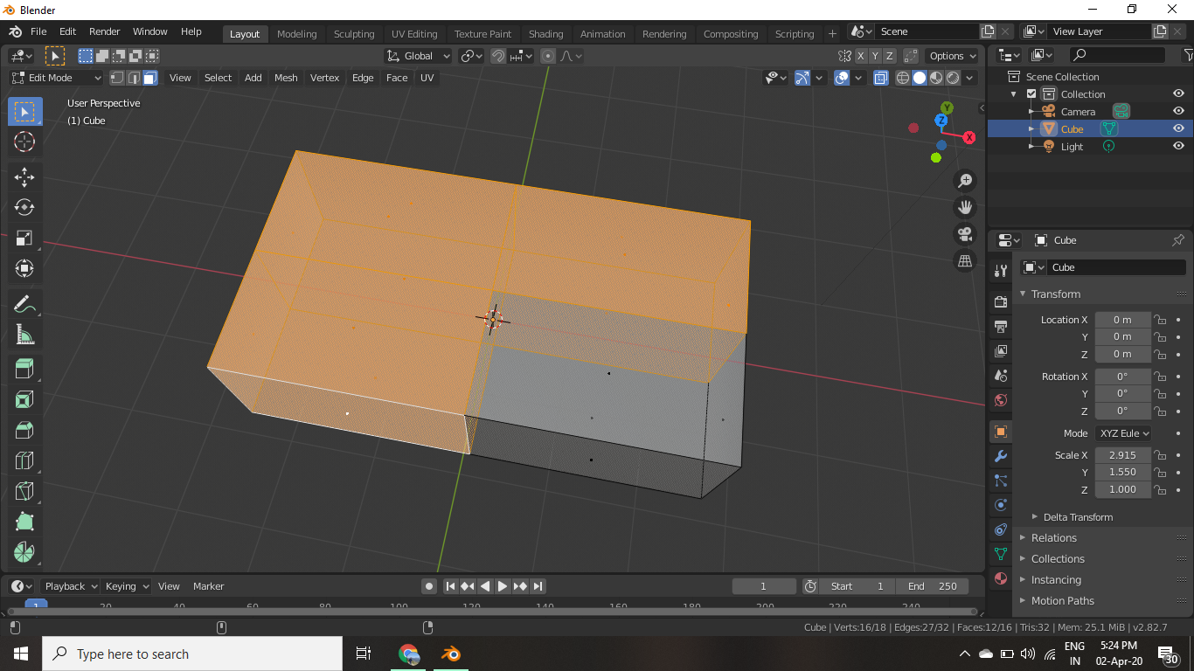
3. Now delete these selected faces. And use “mirror” modifier along the X and Y axis. 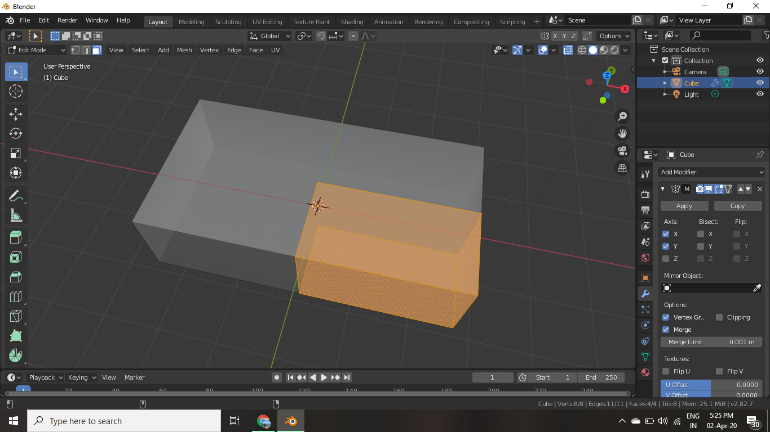
4. Now as boat is a symmetrical object we use mirror modifier so that our changes go symmetrically and we don’t have to do them 3 more times. So now divide the original part in 3 or 4 parts according to the requirement and select the consecutive points and shift them upwards using “G” command like in the figure below.

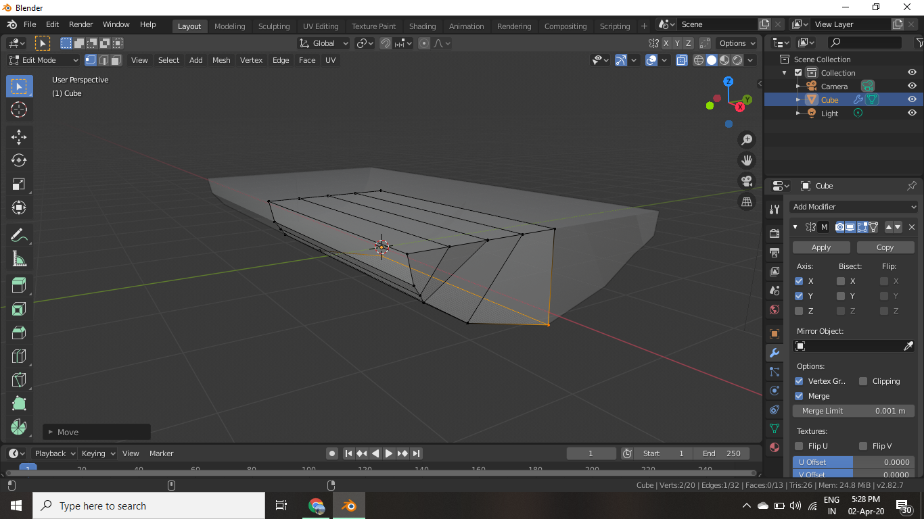

1. Now do the same thing horizontally to give it a shape of boat.

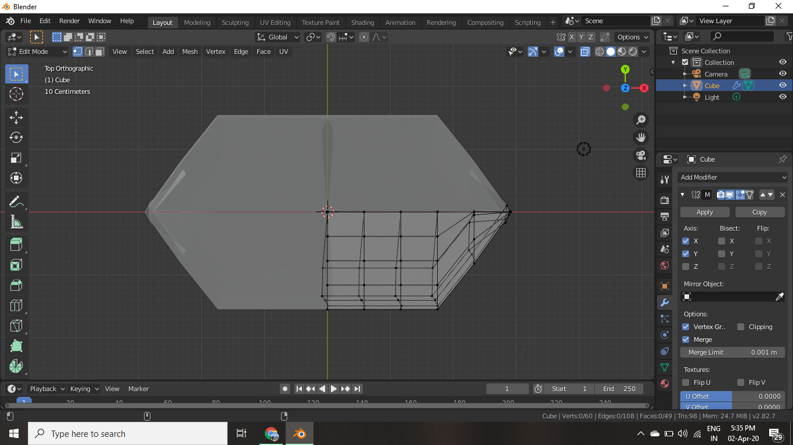

1. Now select the faces and delete them to make the structure hollow and remove the roof of the structure.

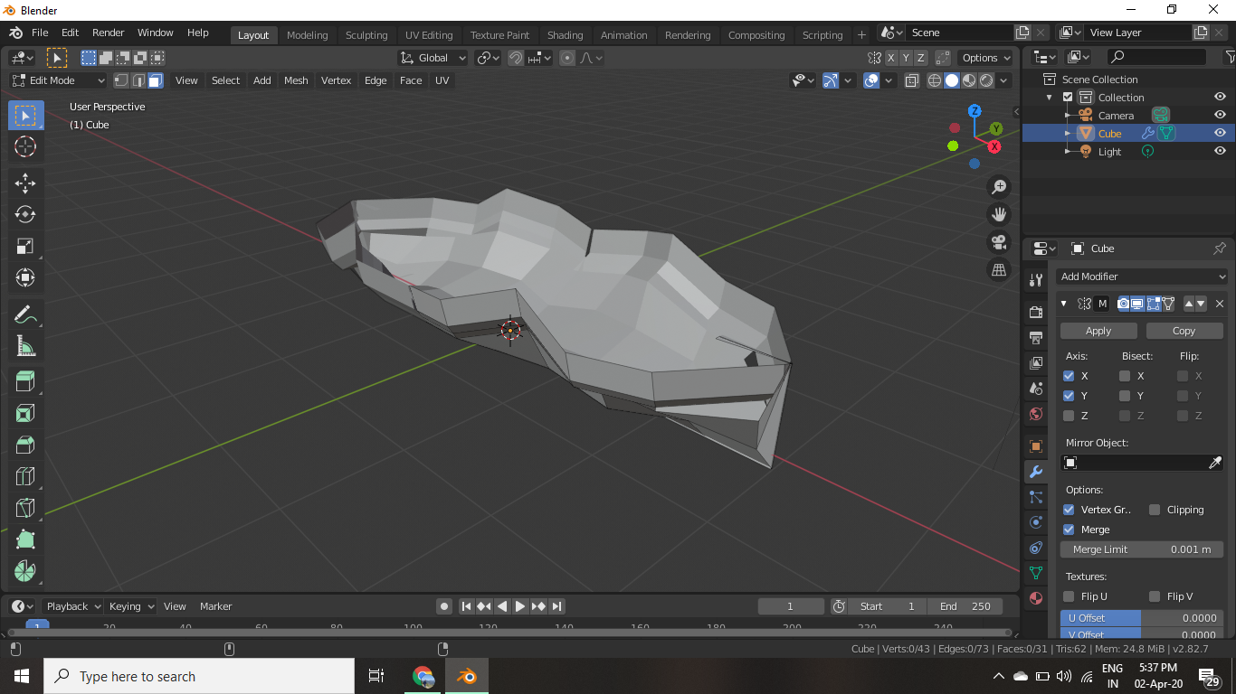

1. Now mould this structure using “g “and editing in small regions to make it a boat.

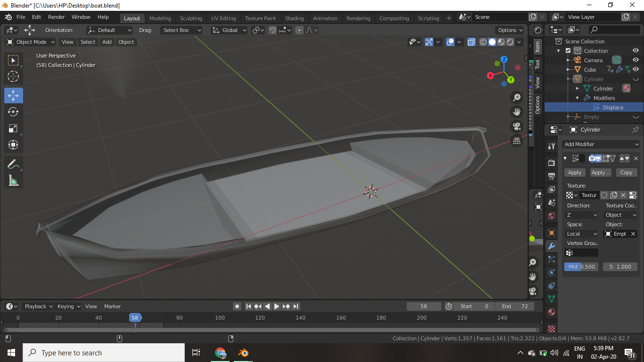

1. Now for making water add a mesh of cylinder. Resize it to your requirements then add modifier “subdivision surface” it will make it like a bun and for waves use modifier “displacement” and then use “voronoi” setting then play with “intensity” to give it a water like formation.

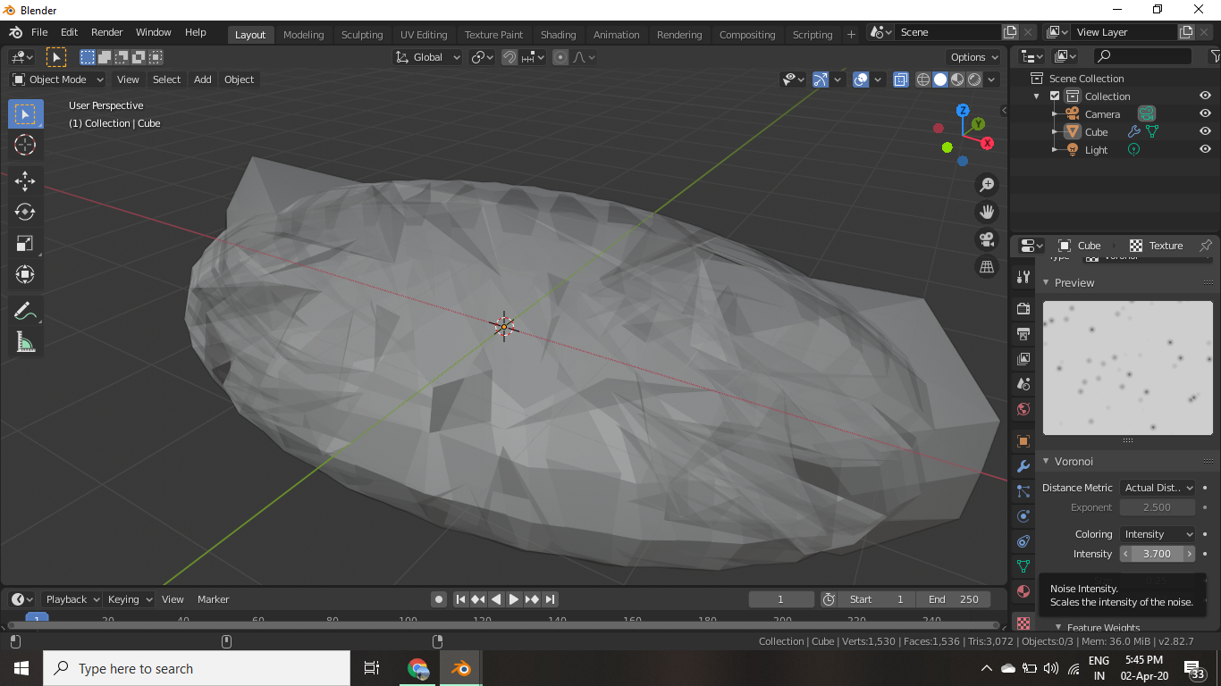

1. Now for the animation use an empty mesh of any kind I used a cube. Then link this with the water by using “Cast” modifier and object on empty mesh then you can control water by rotating empty mesh for animation.

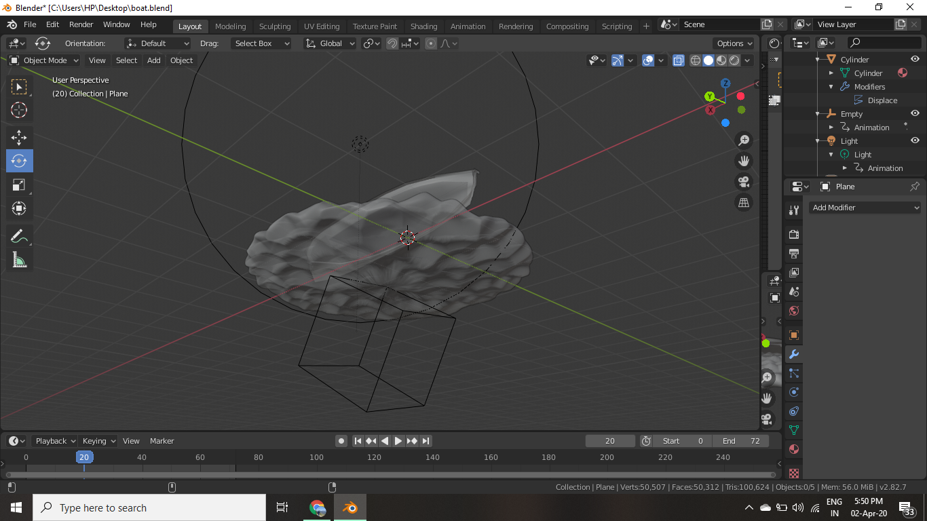

1. For animation open the menu from the top right corner then select the empty mesh and move it accordingly and insert the key points to animate the water. 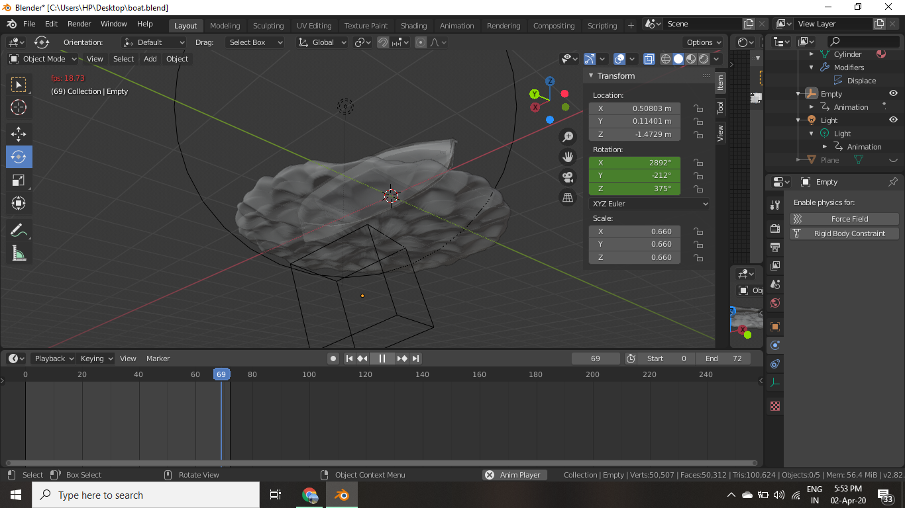
2. Do the same with the boat by selecting boat and rotating it. 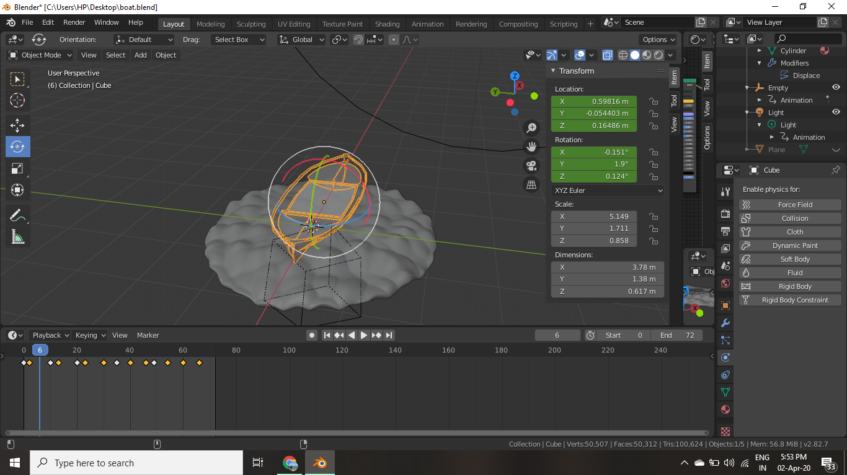

1. Now set the camera and lighting. In this I have set light near 5000 w and camera is orthographic. 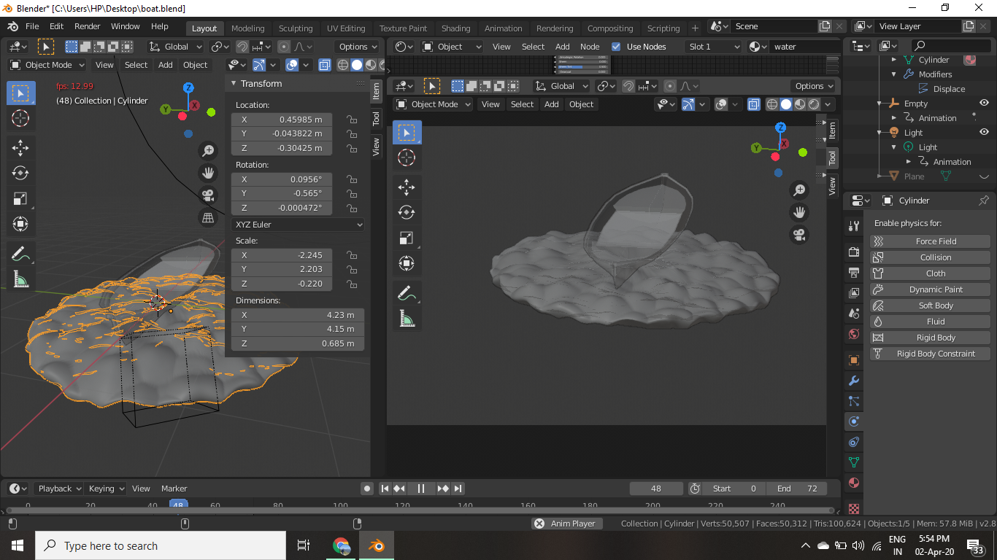
2. Now add colours to boat and water using shader editor in a new tab.

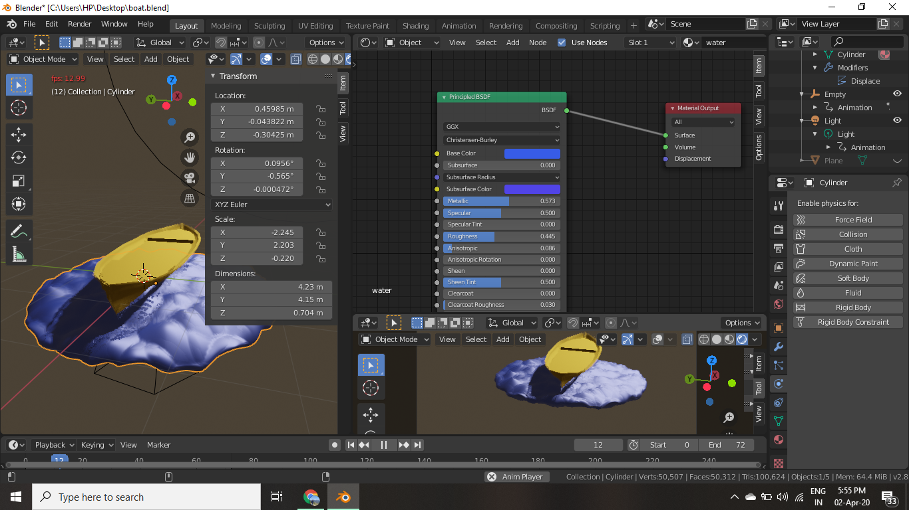

# References

1. Boat: <https://www.youtube.com/watch?v=YG4Ky6LG9XY>
2. Water And Animation: <https://www.youtube.com/watch?v=M6ROAZnyMqo>